**Module -11 Assignment**

**Q1.) Create a navigation bar similar to the below-mentioned image. The navigation bar must contain 5 navigation links that are properly placed within the navigation bar using the CSS box model. The navigation items must change their text color on hover.**

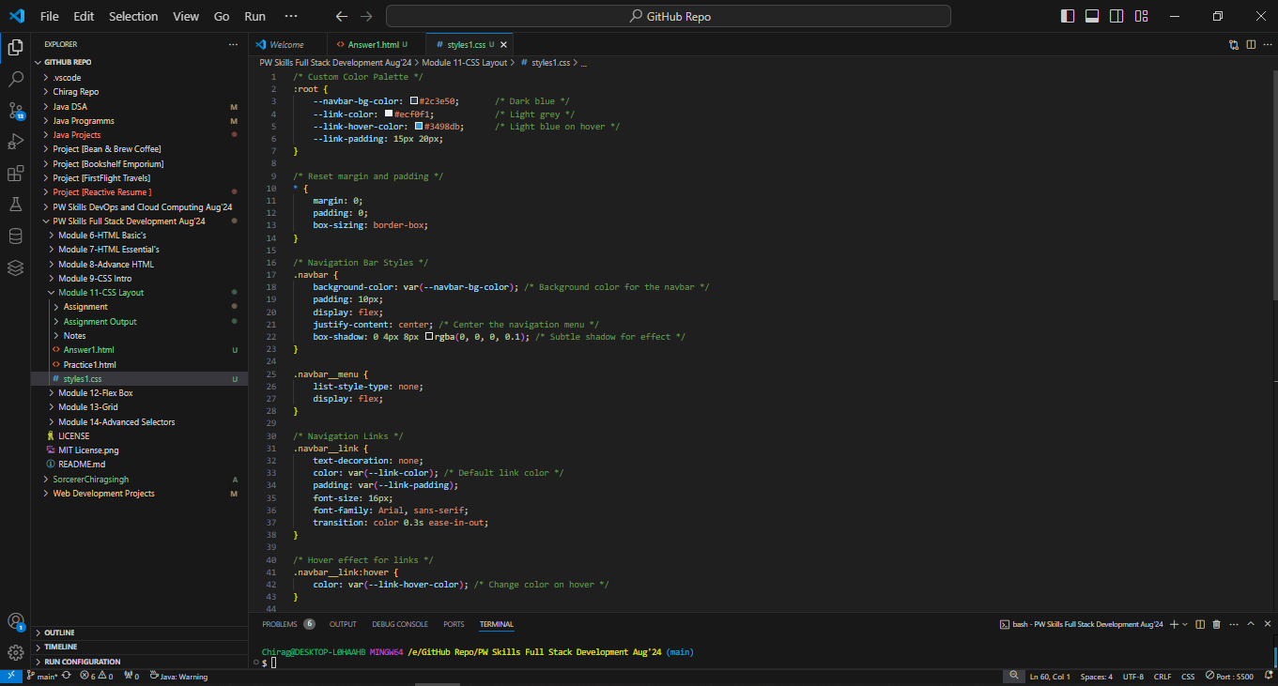

**Q2.) Create a div centered with an image and paragraph similar to the image mentioned below.**

**Q3.) Create a navigation bar similar to question 1. For each navigation item, use a different border style.**

**Q4.) Create a simple webpage with an image and make the image circular using border-radius.**

**Q5.) Create a simple blog website about Google fonts. The webpage must have the heading with “Oswald” font align center to the page, below the heading have an image of Google fonts and a paragraph about Google fonts in font “Montserrat” paragraph font style should be “montserrat” font.**

**Q6.) Create a simple website as mentioned in the below image. You can get the assets by visiting** [**https://pwskills.com/about-us**](https://pwskills.com/about-us)**.**

**Q7.) Create a simple webpage with a card similar to question number 2. The card must be semi-transparent as default and on hovering the card must be displayed clearly. Use CSS opacity to achieve this output.**

**1.Without hover**

**2.After hover**

**Q8.) Create a simple list of items as mentioned in the below image.**

